BFU: Free Trade
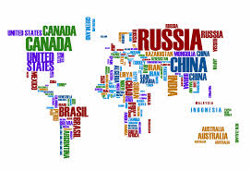

Misconception:

Economics always helped everyone…

Think about today.
Here is a map of the economically powerful countries:
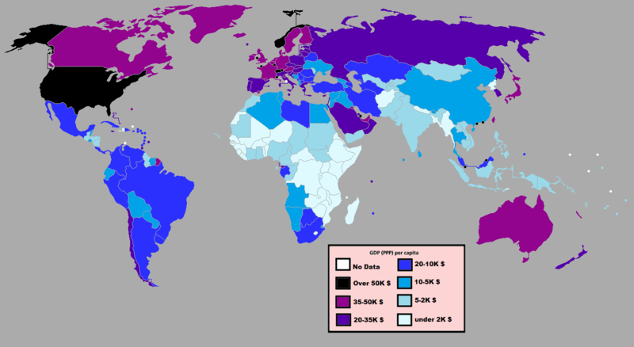
The USA, Western Europe, and Japan dominate. Is it because they have the most factories? No!
Developed now includes new industries like computers, telecommunications, healthcare, services, biotechnology, and entertainment.

We divide the world into the Developed World and the Developing World.

The Developed Countries are Europe, USA, Japan, South Korea, Hong Kong, Israel, and some Gulf Arab States.

The faster Developing Countries are Brazil, India, China, Mexico, Peru, South Africa, and Southeast Asia.

The rest of the world is developing more slowly but still developing.

Countries like Ethiopia, for example, are developing with investments from the USA, China, Saudi Arabia, and France.

If there’s something to sell, there will always be somebody to buy it. This is capitalism. Because all countries are so connected, we call it global capitalism. The process is called globalization.

Global companies want free trade.

Free trade is like a promise that governments make not to interfere in business. They promise to keep taxes low. They promise not to make regulations.

Complete

1. What are some developed countries?
Europe, USA, Japan, South Korea, Hong Kong, Israel, and some Gulf Arab States.
2. What are some developing countries?
Brazil,India, China, Mexico, Peru, South Africa, and Southeast Asia.

3. How do we divide the world now?We divide the world into the Developed World and the Developing World.

Some examples of Free Trade Organizations include:

WTO: World Trade Organization | The world trade agreement
NAFTA: North American Free Trade Association | USA, Mexico, and Canada
EU: European Union | Europe

The world is so connected that there are many organizations that act like banks for the world. They include:

IMF: International Monetary Fund | They give loans to countries to grow their economies
World Bank | They also give loans to countries to grow their economies
United Nations | This is a world governing body but they also work with economies.

Free trade allows new technologies to cross borders without delays. Computers and the internet open up borders so that we know what’s going on around the world without having to wait.

Complete
1. What are some Free Trade organizations?
World Trade Organization, North American Free Trade Association, and European Union

2. What are some “World Banks” that promote free trade?
International Monetary Fund, World Bank and United Nation.

3. The IMF, WTO, NAFTA, and World Bank all want what kind of trade?
They want free trade.
4. What does Free Trade mean?
free trade allows new technologies to cross borders without delays.
It’s hard to even think about “Borders” because everyone has family in different places. Refugees are common all over the world. It’s not just in the United States, where people cross the Mexican border to look for jobs.
It’s also in Europe and Arabia, where Africans and Asians come as “migrant” workers and make a new life for themselves.
Some people have many nationalities and have trouble identifying with just one.

Corporations are also multi-national. They include people and products from different nations. Multinational corporations aren’t loyal to one country. Apple is not an American company; it is a global company.

Honda is a “Japanese Car” but most of its factories are in the USA. Honda creates more jobs for Americans than many other “American” products. So, we can’t even say Honda is “Japanese.” It is multinational.
But there are problems with free trade. There are problems with globalization.

Rewrite
1. Most developed countries nowadays are all the same nationalities.

2. Multinational corporations belong to many countries.

3. Honda is Japanese and is mostly made in USA.

4. Globalization is the process of the global economy coming together.
Anecdote: Free Trade at Ford!

Imagine it is the 1950s. You work for Ford Motor Company. You live in Detroit. Your job is in a factory. You make steering wheels. You don’t need an education; you just have to show up for work.

Your life is good. You can buy a house. You can afford a car. You have a nice family. You tell your son: “Boy, you should be just like me and work hard. Life will be good to you.”

You retire to Florida. You sell your son that house that you earned with your factory wages.

Look at your house now:
Your son was working at that same factory. He lost his job. He doesn’t have an education, so he is unemployed.

Look at your son now:
What happened?
In the 1980s, all of the car companies left Detroit. They couldn’t afford to pay salaries to factory workers in the USA.

Why? It was cheaper to pay people in Mexico to do the same work. Ford couldn’t compete and stay in the USA.

But it doesn’t stop there. Let’s follow your steering wheel job.

The new Ford factory opens in Chiapas, Mexico. A guy named Juan gets your old job, making steering wheels. He gets paid about $2.50 a day for this job. (You were making $35.00 an hour before you retired.) But Juan is happy. He made much less working in the fields, so he is doing well.

But there are some protests. People demand more money; they point out that gringos got $35.00 an hour for the same job. The Mexican government takes the side of the people and demands that Ford pay higher salaries.

Ford responds: they just move the factory across the border to Guatemala. They pay the Guatemalans even less money.
They say: “If you complain, we will leave. We will go to Honduras, where they want to work.” Juan decides to leave Chiapas and go North to the USA, where he will look for work there.
Answer
1. Where were most of the Ford plants before Free Trade?
Detroit
2. What happened next?
Detroitcouldn’t afford to pay salaries to factory workers in the USA

3. How did Free Trade hurt Ford?
Ford Company had to move to many places because some people complained about their salaries.

These are the problems with free trade and globalization. They are not new problems. They are very old. So, we need to go back to the 1800s and look at how the Industrial Revolution created these problems. The central problem is called inequality.

Inequality can mean many things. We are talking about economic inequality. It divides people into classes, like the upper, the middle, and the lower classes. It divides people into owners and workers. People who aren’t equal don’t have the same access to education. Rich people can send their children to private schools; poor people have to take what they can afford. Rich people don’t have to worry about saving for college; poor people might choose to work instead of college.

Inequality affects healthcare. Rich people have better choices in healthcare, and they also often have healthier lifestyles. They suffer from less stress. Inequality can mean access to the internet. It can mean literacy, which is reading and comprehending. It can be financial literacy, which means understanding how economic systems function and how to best make money.

The more advanced we get; the more obvious of a problem inequality becomes.

Complete
1. Inequality is…many things, but economy is the most important

2. Inequality divides people into….
Classes

Answer
1. What is inequality?Economy inequality

2. What are some bad effects of inequality?
some people have more opportunities in anything than others

3. Do you think inequality gets better or worse with free trade? It gets worse because not everyone has the same class of economy

Summary Complete
1. Globalization is…trade between countries
2. The world is divided between…Developed World and Developing World
3. Free trade means…allows new technologies to cross borders without delays.
4. Some free trade organizations are…World Trade Organization, North American Free Trade Association, and European Union

5. It’s difficult to think about borders because…everyone has family in different places.
6. Inequality means…many things including economy

